DAVID ANDERSON HIGH SCHOOL
COLLEGE CREDIT PLUS NIGHT

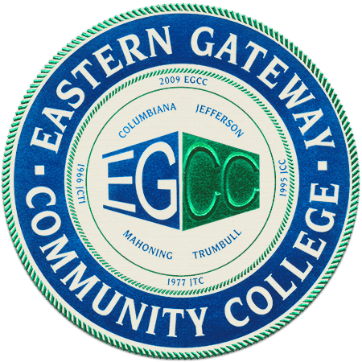

What is College Credit Plus?
- Opportunity to earn college credit while at David Anderson High School
- Open to all David Anderson Junior/Senior High School students grades 6-11
- Take classes at University campuses or online
- No cost to students
CCP Information Night:
Attend our informational meeting at Kent State Salem Campus to find out more information regarding eligibility, enrollment, and college coursework offered. Representatives from Eastern Gateway Community College, Kent State University Columbiana County and Youngstown State University will attend.
Who should attend?
Any family with a student considering participation in College Credit Plus during the 2024-2025 school year.

COLLEGE CREDIT PLUS NIGHT
Wednesday, December 6, 2023 at 5:30 pm
Kent State University Salem Campus

